**Mini-Project**

**Name – Swaraj Santosh Pawar**

**Employee ID – 5852**

**Mini-Project on Designing Travelling Website**

**Understanding**

To make a mini-project using “HTML & CSS”. Creating a basic website which has navigation bar,

**Problem Statement**

A travel website is a website that provides travel reviews, trip fares, or a combination of both. Over 1.5 billion people book travel per year, 70% of which is done online. We want to Design a website. While making website we are using HTML & CSS.

**Algorithm**

**1. HTML Structure** - Define the basic HTML structure with <!DOCTYPE html>, <html>, <head>, and <body> tags.

**2. Header Section** - Create a header section containing the website logo, navigation menu, and search bar.

**3. Navigation Menu** - Build a responsive navigation menu with links to different sections of the website.

**4. Main Banner** - Include a main banner section with images and text showcasing featured travel destinations.

**5. Search and Filters Form** - Design a form for users to input search criteria and filters using HTML form elements.

**6. Package Listings** - Use HTML elements to display travel packages, including images, Names, and pricing.

**7. User Reviews Section** - Design a section to display user reviews and ratings for different travel packages.

**8. Interactive Maps** **Section** - Embed interactive maps using HTML and include markers for destinations and attractions.

**9. Footer Section** - Use HTML elements to display Copyright year , Social Media link Handling , Contact Us ,Refund Policy , FAQ and much more.

**10. Cascading Style Sheets (CSS) -** CSS is used for styling. Use CSS to Align Elements , align images & text , change background colour , change colour , change font size and colour, padding , border-radius, width, Height , Margin etc.

**HTML CODE**

<!DOCTYPE html>

<html lang="en">

<head>

    <meta charset="UTF-8">

    <meta name="viewport" content="width=device-width, initial-scale=1.0">

     <link rel="stylesheet" href="style.css">

     <script src="https://kit.fontawesome.com/c1f28cf387.js" crossorigin="anonymous"></script>

    <title>Staybnb</title>

</head>

<body>

    <div class="header">

        <nav id="navBar">

            <img src="images/logo.png" class="logo">

            <ul class="nav-links">

                <li><a href="#" class="active">Popular Places</a></li>

                <li><a href="#">Travel Outside</a></li>

                <li><a href="#">Online Packages</a></li>

            </ul>

            <a href="#" class="register-button">Register Now</a>

            <i class="fas fa-bars" onclick="togglebtn()"></i>

        </nav>

        <div class="container">

            <h1>Find Your Next Stay</h1>

            <div class="Search-bar">

                <form>

                    <div class="location-input">

                        <label>Location</label>

                        <input type="text" placeholder="Where are you going?">

                    </div>

                    <div>

                        <label>Check in</label>

                        <input type="text" placeholder="Add Date">

                    </div>

                    <div>

                        <label>Check Out</label>

                        <input type="text" placeholder="Add Date">

                    </div>

                    <div>

                        <label>Guest</label>

                        <input type="text" placeholder="Add Guest">

                    </div>

                    <button type="submit"><img src="images/search.png"></button>

                </form>

            </div>

        </div>

    </div>

<div class="container">

    <h2 class="sub-title">Exclusives</h2>

    <div class="exclusives">

    <div class="row3">

        <img src="images/image-1.png">

        <span>

            <h3>London</h3>

            <p>Starts @ ₹69,999/person</p>

        </span>

    </div>

    <div class="row3">

        <img src="images/image-2.png">

        <span>

            <h3>Swizerland</h3>

            <p>Starts @ ₹59,999/person</p>

        </span>

    </div>

    <div class="row3">

        <img src="images/image-3.png">

        <span>

            <h3>Australia</h3>

            <p>Starts @ ₹69,999/person</p>

        </span>

    </div>

    <div class="row3">

        <img src="images/image-4.png">

        <span>

            <h3>France</h3>

            <p>Starts @ ₹69,999/person</p>

        </span>

    </div>

    <div class="row3">

        <img src="images/image-5.png">

        <span>

            <h3>Amsterdam</h3>

            <p>Starts @ ₹69,999/person</p>

        </span>

    </div>

    <div class="row3">

        <img src="images/image-6.png">

        <span>

            <h3>Canada</h3>

            <p>Starts @ ₹59,999/person</p>

        </span>

    </div>

    <div class="row3">

        <img src="images/image-7.png">

        <span>

            <h3>New York</h3>

            <p>Starts @ ₹79,999/person</p>

        </span>

    </div>

    <div class="row3">

        <img src="images/image-8.png">

        <span>

            <h3>chicago</h3>

            <p>Starts @ ₹79,999/person</p>

        </span>

    </div>

    <div class="row3">

        <img src="images/image-9.png">

        <span>

            <h3>San Francisco</h3>

            <p>Starts @ ₹69,999/person</p>

        </span>

    </div>

    <div class="row3">

        <img src="images/image-10.png">

        <span>

            <h3>Shanghai</h3>

            <p>Starts @ ₹49,999/person</p>

        </span>

    </div>

</div>

<h2 class="sub-title">Trending Places</h2>

<div class="trending">

  <div class="row3">

    <img src="images/dubai.png"

    <h3>Dubai</h3>

  </div>

  <div class="row3">

    <img src="images/new-york.png"

    <h3>New York</h3>

  </div>

  <div class="row3">

    <img src="images/paris.png"

    <h3>Paris</h3>

  </div>

  <div class="row3">

    <img src="images/new-delhi.png"

    <h3>Australia</h3>

  </div>

</div>

<div class="cta">

    <h3>Sharing <br>is Earning Now</h3>

    <p>Great Opportunity to make money by <br>sharing your extra space.</p>

    <a href ="#" class="cta-btn">Know More</a>

</div>

<h2 class="sub-title">Travellers Stories</h2>

<div class="stories">

    <div class="row3">

        <img src="images/story-1.png">

        <p>Popular European Countries with a Budget of just $10,000</p>

    </div>

    <div class="row3">

        <img src="images/story-2.png">

        <p>Travelled More than 100 Countries in less than a year</p>

    </div>

    <div class="row3">

        <img src="images/story-3.png">

        <p>Best experience you get while travelling to thailand</p>

    </div>

</div>

<a href="#" class="start-btn">Start Making Money</a>

<div class="about-msg">

    <h2>About Us</h2>

    <p>We specialize in crafting personalized journeys that transform vacations into unforgettable adventures. Our expertise lies in providing tailored itineraries, global destinations, and seamless planning, ensuring your travel dreams become a reality. From enticing vacation packages to efficient corporate travel solutions and specialized tours, we cater to diverse travel interests. What sets us apart is our unwavering commitment to customer satisfaction, experienced guides, and a focus on sustainable travel practices. Choose Staybnb for a travel experience beyond the ordinary – where your journey is our priority. Welcome to a world of unparalleled exploration!</p>

</div>

<div class="footer">

     <a href="https://facebook.com"><i class="fa-brands fa-facebook"></i></a>

     <a href="https://youtube.com"><i class="fa-brands fa-youtube"></i></a>

     <a href="https://twitter.com"><i class="fa-brands fa-twitter"></i></a>

     <a href="https://linkedin.com"><i class="fa-brands fa-linkedin"></i></a>

     <a href="https://instagram.com"><i class="fa-brands fa-instagram"></i></a>

    <hr>

    <a href="#">FAQ</a>

    <a href="#">Contact Us</a>

    <a href="#">Terms of Use</a>

    <a href="#">Privacy Policy</a>

    <a href="#">Refund Policy</a>

    <a href="#">Copyright &copy; 2023 | Staybnb</a>

  </div>

</div>

<script>

    var navBar = document.getElementById("navBar");

    function togglebtn(){

        navBar.classList.toggle("hidemenu")

    }

</script>

</body>

</html>

**CSS CODE**

* {

  margin: 0;

  padding: 0;

  box-sizing: border-box;

  font-family: "poppins", sans-serif;

}

.header {

  min-height: 100vh;

  width: 100%;

  background-image: linear-gradient(rgba(0, 0, 0, 0.3), rgba(0, 0, 0, 0.3)),

    url(images/banner.png);

  background-size: cover;

  background-position: center;

}

nav {

  display: flex;

  align-items: center;

  justify-content: space-between;

  padding: 20px 7%;

}

.logo {

  width: 140px;

  cursor: pointer;

}

.nav-links li {

  list-style: none;

  display: inline-block;

  margin: 10px 30px;

}

.nav-links li a {

  text-decoration: none;

  color: #fff;

}

.register-button {

  background: #fff;

  color: #000;

  padding: 8px 20px;

  border-radius: 20px;

  text-decoration: none;

  font-size: 14px;

}

.container {

  padding: 0 7%;

}

.header h1 {

  font-size: 4vw;

  font-weight: 500;

  color: #fff;

  text-align: center;

  padding-top: 22%;

}

.Search-bar {

  background: #fff;

  width: 70%;

  margin: 30px auto;

  padding: 6px 10px 6px 30px;

  border-radius: 50px;

}

.Search-bar form {

  display: flex;

  align-items: center;

  flex-wrap: wrap;

}

.Search-bar form input {

  display: block;

  border: 0;

  outline: none;

  background: transparent;

}

.Search-bar form button {

  background: #ff5361;

  width: 55px;

  height: 55px;

  border-radius: 50%;

  border: 0;

  outline: none;

  cursor: pointer;

}

.Search-bar form button img {

  width: 15px;

  margin-top: 7px;

}

.location-input {

  flex: 1;

}

.Search-bar form label {

  font-weight: 600;

}

*/*---------exclusives---------*/*

.sub-title {

  margin: 50px 0 20px;

  font-size: 2.2vw;

  font-weight: 500;

  color: #333;

}

.exclusives {

  display: grid;

  grid-template-columns: repeat(auto-fit, minmax(200px, 1fr));

}

.exclusives div img {

  width: 100%;

  border-radius: 20px;

}

.exclusives div {

  position: relative;

}

.exclusives div span {

  position: absolute;

  top: 50%;

  left: 50%;

  transform: translate(-50%, -50%);

  text-align: center;

  color: #fff;

}

*/*--------------Trending places---------------*/*

.trending {

  display: grid;

  grid-template-columns: repeat(auto-fit, minmax(200px, 1fr));

  margin-bottom: 30px;

}

.trending div img {

  width: 100%;

  border-radius: 20px;

}

.trending h3 {

  font-weight: 600;

  margin-top: 10px;

}

*/*--------------Call to action---------------*/*

.cta {

  margin: 80px 0;

  background-image: linear-gradient(to right, #3f2321, transparent),

    url(images/banner-2.png);

  background-size: cover;

  background-position: center;

  border-radius: 10px;

  padding: 5%;

  color: #fff;

}

.cta h3 {

  font-size: 4vw;

  line-height: 5.3vw;

  font-weight: 500;

}

.cta p {

  font-size: 18px;

  margin: 10px 0;

}

.cta-btn {

  background: #ff5361;

  color: #fff;

  text-decoration: none;

  padding: 12px 30px;

  border-radius: 8px;

  margin-top: 20px;

  display: inline-block;

}

*/*--------------Traveller Stories---------------*/*

.stories {

  display: grid;

  grid-template-columns: repeat(auto-fit, minmax(200px, 1fr));

  margin-bottom: 30px;

}

.stories div img {

  width: 100%;

  border-radius: 10px;

}

.stories div {

  position: relative;

  text-align: center;

}

.stories p {

  width: 80%;

  position: absolute;

  top: 50%;

  left: 50%;

  transform: translate(-50%, -50%);

  color: #fff;

  font-size: 26px;

}

.start-btn {

  text-decoration: none;

  background: #ff5361;

  color: #fff;

  width: 80%;

  max-width: 350px;

  display: block;

  text-align: center;

  margin: 60px auto;

  padding: 15px;

  border-radius: 30px;

  font-size: 20px;

}

.about-msg {

  text-align: center;

  margin: 80px 0; */* text-height from bottom of the Page*/*

  color: #333;

  font-size: 17;

}

.about-msg h2 {

  font-size: 28px;

  margin-bottom: 30px; */* text-height from paragraph*/*

  font-weight: 500;

}

*/*--------------Footer---------------*/*

.footer {

  margin: 80px 0 10px;

  text-align: center;

}

.footer a {

  text-decoration: none;

  color: #333;

  font-size: 20px;

  margin: 0 10px;

}

.fotter hr {

  background: black;

  height: 1px;

  width: 100px;

  border: 0;

  margin: 20px 0;

}

.footer p {

  padding: 15px;

}

.active {

  position: relative;

}

.active::after {

  content: "";

  background: #fff;

  width: 25px;

  height: 2px;

  position: absolute;

  left: 50%;

  transform: translateX(-50%);

  bottom: -12px;

  border-radius: 2px;

}

nav .fa-bars {

  display: none;

}

.row3{

  padding: 0.5rem;

}

*/*--------------For Small Screen Devices---------------*/*

@media only screen and (max-width: 700px) {

  .logo {

    position: fixed;

    top: 4%;

    left: 7%;

  }

  nav {

    position: fixed;

    top: 0;

    z-index: 100;

    display: inline-block;

    width: 100%;

    padding: 100px 7% 0;

    background: #000;

    text-align: right;

    max-height: 100px;

    overflow: hidden;

    transition: max-height 0.5s;

  }

  nav .nav-links li {

    margin: 10px 0;

    display: block;

  }

  .register-button {

    margin: 15px 0 30px;

    display: inline-block;

  }

  nav .fa-bars {

    display: block;

    position: fixed;

    top: 4%;

    right: 7%;

    color: #fff;

    font-size: 28px;

  }

  .active::after {

    left: -40%;

    transform: translate(0, 50%);

    bottom: 50%;

  }

  .hidemenu {

    max-height: 300px;

  }

  .header h1 {

    padding-top: 200px;

    font-size: 7vw;

  }

  .Search-bar {

    width: 90%;

    margin: 30px auto;

    padding: 20px 10px 30px;

    border-radius: 5px;

    position: relative;

  }

  .Search-bar form {

    display: block;

  }

  .Search-bar form input {

    border-bottom: 1px solid #ddd;

    width: 100%;

    margin-bottom: 20px;

    margin-top: 10px;

    padding-bottom: 10px;

  }

  .Search-bar form button {

    position: absolute;

    bottom: 0;

    left: 50%;

    transform: translate(-50%, 50%);

  }

  .sub-title {

    font-size: 6vw;

  }

  .cta {

    padding: 15% 5%;

  }

  .cta h3 {

    font-size: 7vw;

    line-height: 8vw;

  }

  .cta p {

    font-size: 14px;

  }

  .cta-btn {

    padding: 6px 15px;

    border-radius: 4px;

    margin-top: 10px;

    font-size: 14px;

  }

  .stories p {

    font-size: 22px;

  }

  .about-msg {

    font-size: 15px;

  }

  .footer a {

    font-size: 10px;

    color: black;

  }

}

**OUTPUT WEBSITE IMAGES**

**Image - 1**

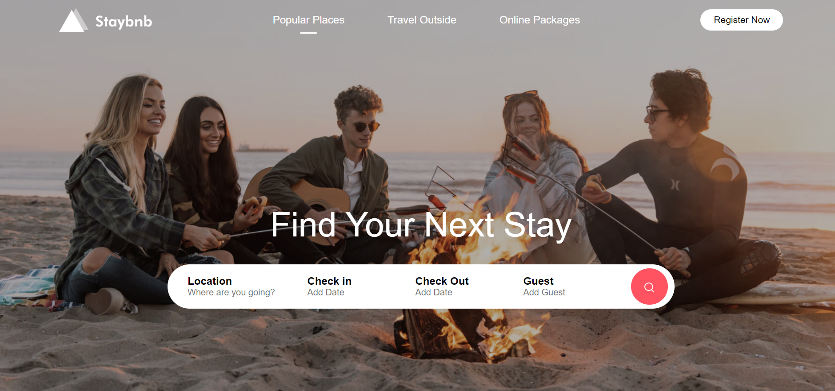

**Image - 2**

In this section there are Exclusives destinations with Exclusive Offers.

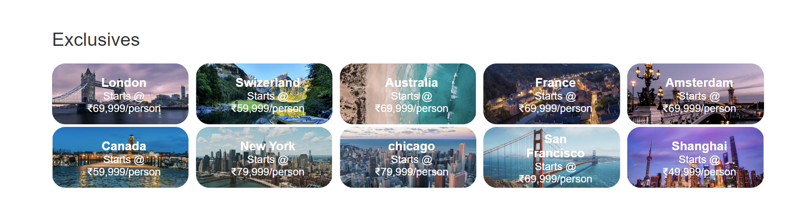

**Image - 3**

This section consists of Trending Places from all Destination Lists.

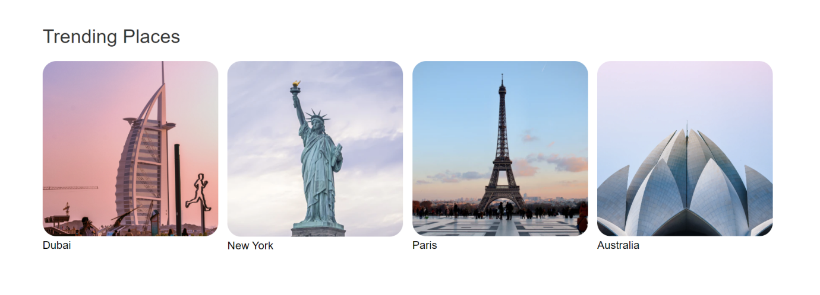

**Image - 4**

In this section we can add advertisement of our new products which are available with travelling. For example – Hotels rooms , Restaurants etc.

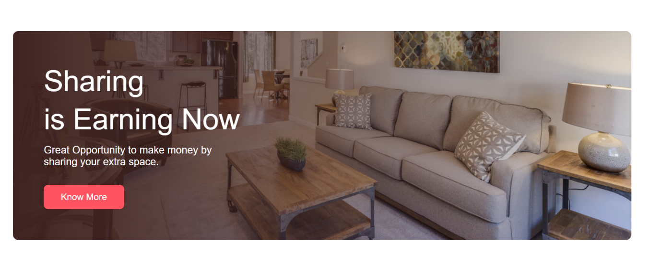

**Image - 5**

In this section there are travellers Stories of various destinations they have visited.

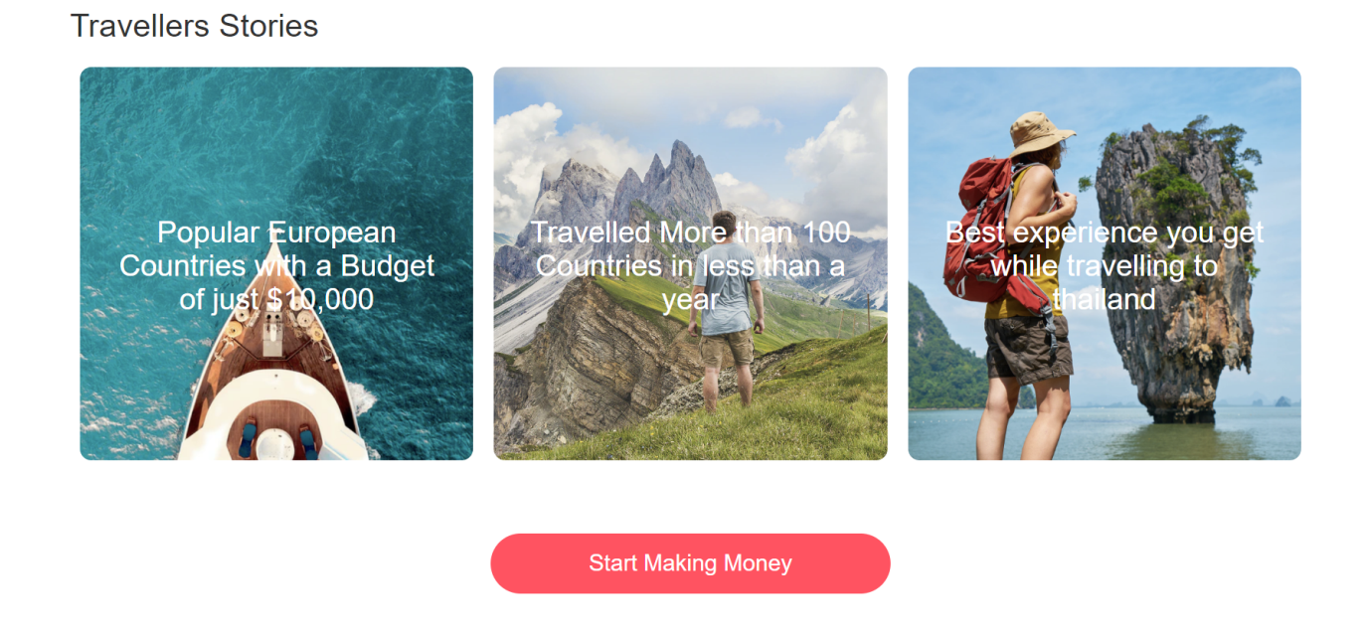

**Image - 6**

In this Section there is “About Us” section which has short description about company and social media handles link.

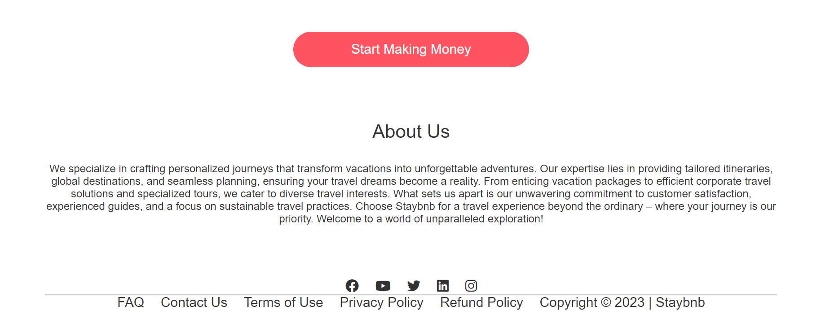

**Small Screen View (Smart Phones)**

